http://h20566.www2.hp.com/portal/site/hpsc/template.PAGE/public/psi/swdDetails/?lang=en&cc=US&swItem=MTX_a731cab0cd5649ca92ddccdf1d

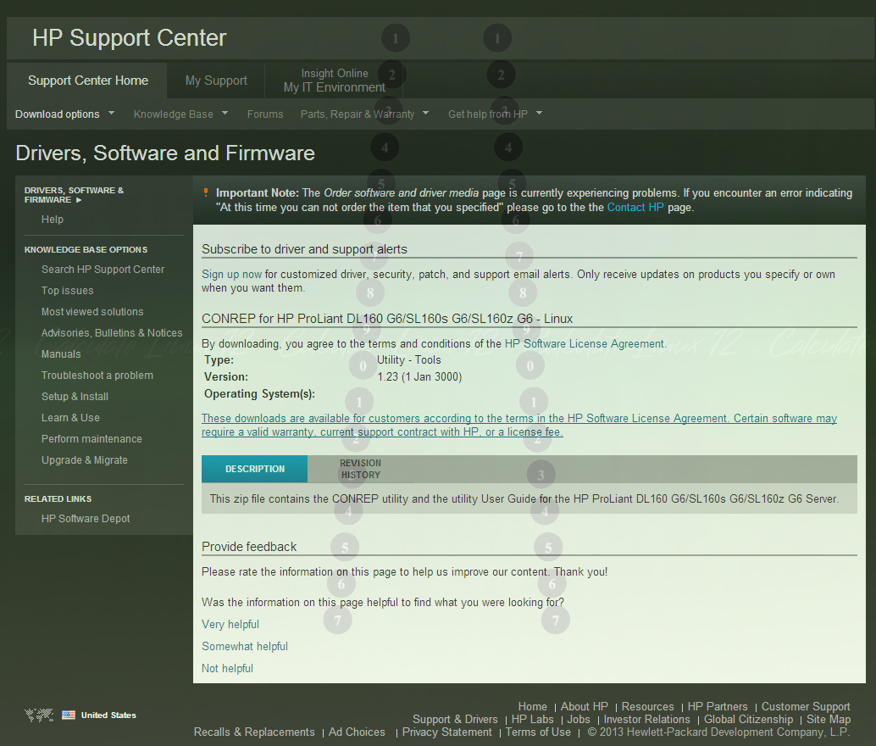

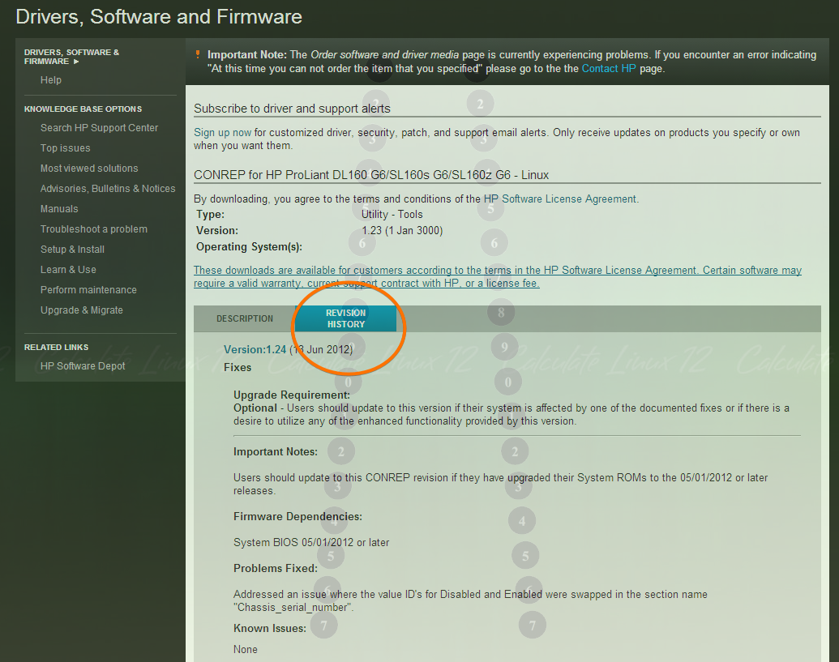

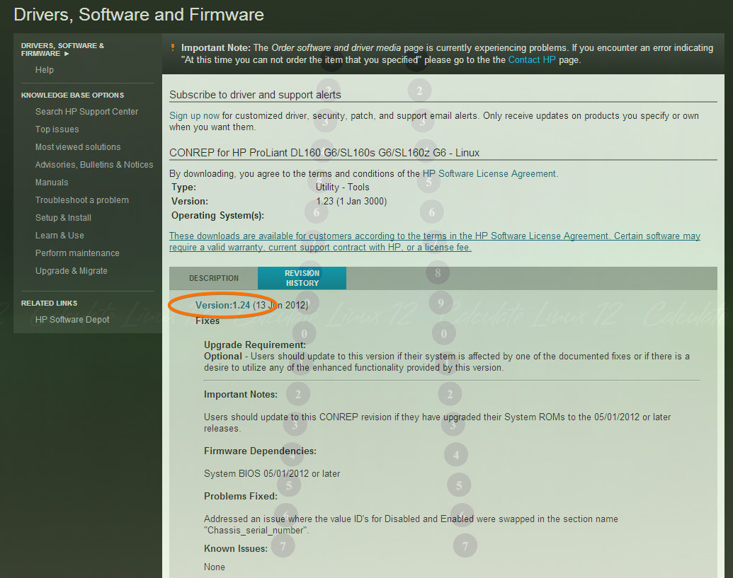

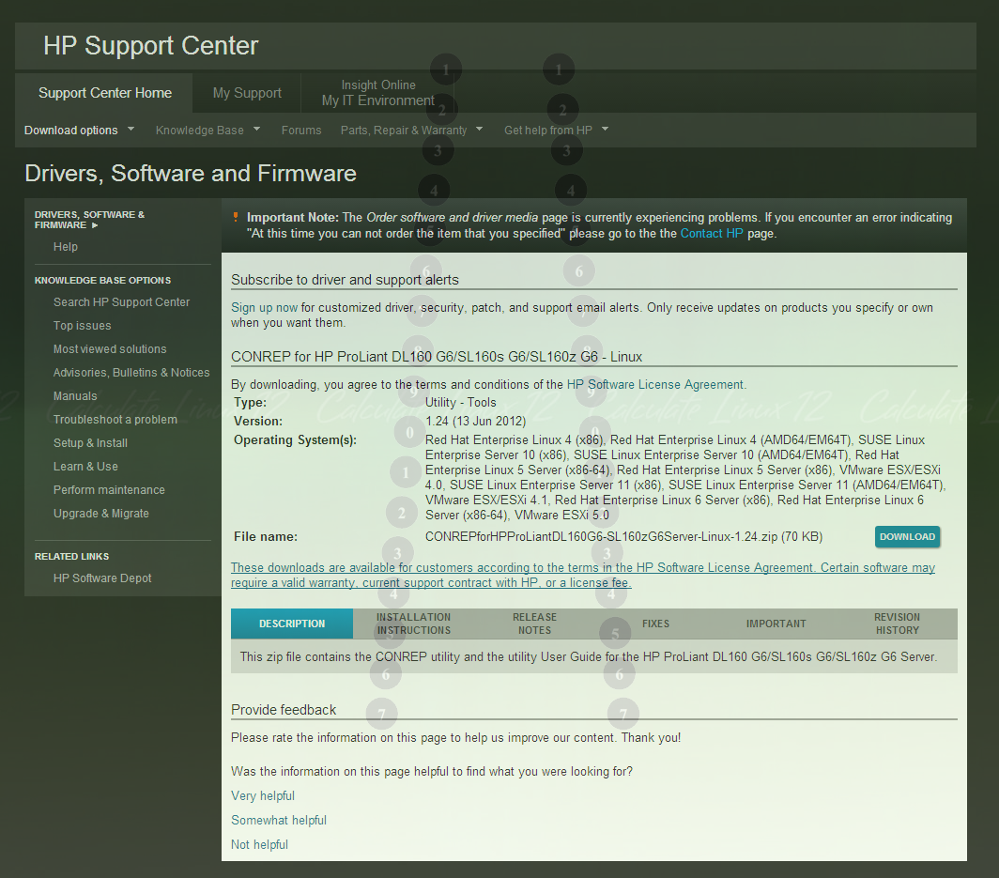

https://groups.google.com/forum/#!msg/pdxdevops/8yu24u9AtkU/NDfmOLXdLnAJ

Hi,

I was at the PDXdevops meeting last night and I was asked a question on whether or not I had been able to automate bios settings since I had previously given a speech on automating HP ilo settings. Turns out I didn't know the answer but felt very optimistic this level of automation could be done. After about an hour of research I found a solution.

HP Smart start script toolkit for linux and windows.

In this toolkit there is a tool called conrep which gets/sets the bios settings. At first I was afraid the settings were saved in a binary file format but to my surprise its all based in XML. With this level of abstraction it would be very simple to query bios settings and additionally automate the deployment of settings from within puppet or foreman (smart proxy). One of the first tasks that come to mind are PXE boot order setting. Below are the steps to get and set the bios. Further below is the output from my HP DL380 G4 bios config as outputted by conrep. Furthermore, there is also a tool called bootorder which changes just the boot order for HP systems. If your using non-HP hardware your out of luck but I am sure that IBM, Dell and others have similar deployment toolkits that can set bios settings from a script.

ftp://ftp.hp.com/pub/c-products/servers/management/smartstart/LinuxUserGuide(415597-401).pdf

Page 9, step 8

- Capture the system BIOS configuration using the CONREP utility:
- cd /mnt/toolkit_share/utilities
- ./conrep -s -f/mnt/toolkit_share/data_files/conrep.dat

- Apply the system BIOS configuration using the CONREP utility:
- cd /mnt/toolkit_share/utilities
- ./conrep -l -f/mnt/toolkit_share/data_files/conrep.dat

Toolkit download for linux:

http://tinyurl.com/3q2h7vn

<?xml version="1.0" encoding="UTF-8"?>
<!--generated by conrep version 3.30-->
<Conrep version="3.30" originating_platform="ProLiant DL380 G4" originating_family="P51" originating_romdate="10/10/2005" originating_processor_manufacturer="Intel">
<Section name="IPL_Order" helptext="Current Initial ProgramLoad device boot order.">
<Index0>00 </Index0>
<Index1>01 </Index1>
<Index2>03 </Index2>
<Index3>02 </Index3>
<Index4>04 </Index4>
<Index5>ff </Index5>
<Index6>ff </Index6>
<Index7>ff </Index7>
</Section>
<Section name="PCI_Devices" helptext="Lists of PCI devices and their interrupts - not displayed if default values are set.">EMPTY_DELETE</Section>
<Section name="Controller_Order" helptext="Lists the current boot controller ordering.">
<Id0>0e 11 40 91 </Id0>
<Slot0>00 </Slot0>
<BusDev0>04 18 </BusDev0>
<Rest0>41 </Rest0>
</Section>
<Section name="Language" helptext="Defines current language identifier">ENGUSAus </Section>
<Section name="System_WOL" helptext="System Wake On Lan Capabilities.">Enabled</Section>
<Section name="System_APIC" helptext="System APIC Settings(MPS Table Mode).">Full Table</Section>
<Section name="System_Mouse" helptext="Enable or Disable the onboard mouse port.">Enabled</Section>
<Section name="System_CPU_Serial_Number" helptext="Enables or disabled CPU serial numbers on systems that support it.">Disabled</Section>
<Section name="System_COMA" helptext="Settings for UART 1 on systems that support it.">COM1</Section>
<Section name="System_COMA_IRQ" helptext="Settings for UART 1 on systems that support it.">IRQ4</Section>
<Section name="System_COMB" helptext="Settings for UART 2 on systems that support it.">Disabled</Section>
<Section name="System_COMB_IRQ" helptext="Settings for UART 2 on systems that support it.">Undefined</Section>
<Section name="System_Virtual_Serial_Port" helptext="Virtual Serial Port Settings for systems that support it.">COM2</Section>
<Section name="System_Virtual_Serial_Port_IRQ" helptext="Virtual Serial Port IRQ Settings for systems that support it.">IRQ3</Section>
<Section name="System_LPT" helptext="System parallel port settings for systems that support it.">Disabled</Section>
<Section name="System_LPT_IRQ" helptext="System parallel port settings for systems that support it.">Undefined</Section>
<Section name="System_LPT_Mode" helptext="System parallel port settings for systems that support it.">SPP</Section>
<Section name="System_USB_Control" helptext="Systemwide USB settings.">Enabled</Section>
<Section name="System_USB_EHCI_Controller" helptext="Enables or disabled EHCI mode(USB 2.0) of the system USB controller.">Enabled</Section>
<Section name="Diskette_Write_Control" helptext="Toggles write control of integrated floppy.">Writes_Enabled</Section>
<Section name="POST_F1_Prompt" helptext="Controls display of the F1 POST prompt.">Disabled</Section>
<Section name="Hyperthreading" helptext="Toggles hyperthreading on systems that support it. This setting is supported on G5 and earlier systems. For newer systems, use the Intel_Hyperthreading setting.">Enabled</Section>
<Section name="NMI_Debug_Button" helptext="Allows generating NMI(non-maskable interrupt) via NMI button/jumper for hardware debugging.">Enabled</Section>
<Section name="ACPI_Power_Button" helptext="Switches power button to operate in APCI mode. Enabling permits enhanced power button handling(push and hold to shut off, and single push to shutdown) instead of on/off operation.">Enabled</Section>
<Section name="CPU_Performance" helptext="Allows tuning of system performance goals">Memory</Section>
<Section name="ASR" helptext="Allows enabling/disabling of the Automatic Server Recovery feature.">Disabled</Section>
<Section name="ASR_Timeout" helptext="User Configuration Timeout for Automatic Server Recovery">10 Minutes</Section>
<Section name="Thermal_Shutdown" helptext="Enables shutdown when thermal events occur">Enabled</Section>
<Section name="RBSU_Language" helptext="Language to use for the RBSU menus">01</Section>
<Section name="PXE_NIC1" helptext="Enable or disable PXE boot on the given NIC">Enabled</Section>
<Section name="PXE_NIC2" helptext="Enable or disable PXE boot on the given NIC">Disabled</Section>
<Section name="PXE_NIC3" helptext="Enable or disable PXE boot on the given NIC">Disabled</Section>
<Section name="PXE_NIC4" helptext="Enable or disable PXE boot on the given NIC">Disabled</Section>
<Section name="PXE_NIC5" helptext="Enable or disable PXE boot on the given NIC">Disabled</Section>
<Section name="BIOS_Console" helptext="Used to select the port for the BIOS console">Auto</Section>
<Section name="BIOS_Baud_Rate" helptext="BIOS console communications settings">9600</Section>
<Section name="BIOS_Type" helptext="BIOS console communications settings">VT100</Section>
<Section name="EMS_Console" helptext="Used to select the port for the EMS console">Disabled</Section>
<Section name="BIOS_Interface_Mode" helptext="BIOS console communications settings">Auto Mode</Section>
<Section name="System_Embedded_IDE" helptext="Settings for the embedded IDE controller on systems that support it">Enabled</Section>
<Section name="Embedded_Virtual_Disk" helptext="Enables or disable the Virtual Disk when available.">Enabled</Section>
<Section name="No_Execute_Memory_Protection" helptext="Enables No Execute mode if the system CPU supports it">Disabled</Section>
<Section name="Legacy_SERR">Enabled</Section>
<Section name="CPU_Virtualization" helptext="When enabled, a Virtual Machine Manager supporting this feature can utilize hardware capabilities provided by the server.">Disabled</Section>
<Section name="Diskette_Boot">Enabled</Section>
<Section name="NumLock">Off</Section>
<Section name="POST_Speed_Up">Enabled</Section>
<Section name="Integrated_Diskette_Controller">Enabled</Section>
<Section name="PCI_Bus_Reset">Enabled</Section>
<Section name="Hot_Plug_Reservation">Auto Set</Section>
<Section name="Memory_Protection" helptext="Sets the type of memory protection used on the server. Not all modes are supported on all servers.">Advanced_ECC_Support</Section>
<Section name="Automatic_Poweron" helptext="Configures server to automatically power on when A/C power is applied to the system. This setting is not support by blade servers.">Enabled</Section>
<Section name="Power-On_Delay" helptext="Sets the delay for the system to be begin the boot up process">No_Delay</Section>
<Section name="USB_Capability">USB_1.1</Section>
<Section name="PCI_Enumeration_Method" helptext="Controls the PCI enumeration method on G6 or higher servers.">Standard</Section>
<Section name="Option_ROM_Loading_Sequence" helptext="Choses whether Option ROMs for embedded devices or expansion cards are loaded first.">Option_Card_First</Section>
<Section name="Intel_Processor_Core_Disable" helptext="Allows disabling of processor cores using Intel's Core Multi-Processing(CMP) technology.">All_Cores_Enabled</Section>
<Section name="Intel_QPI_Link_Power_Management" helptext="Places the Quick Path Interconnect (QPI) links into a low power state to save power.">Enabled</Section>
<Section name="Memory_Interleaving" helptext="Modifies the level of interleaving for which the memory system will be configured. Typically, higher levels of memory interleaving result in maximum performance, but reducing interleaving level may result in power savings.">Channel_Only_Interleaving</Section>
<Section name="Intel_PCI_Express_Generation_20_Support" helptext="Allows disabling PCI-E Gen 2.0 support on Intel based servers. If disabled, all PCI-Express devices will run at PCI-E 1.0 speeds (2.5 Gb/s) even if a PCI-E device is 2.0 capable (5.0 Gb/s).">Auto</Section>
</conrep>

http://h30499.www3.hp.com/t5/ProLiant-Servers-ML-DL-SL/Bios-Replication-with-conrep-utility/td-p/5831299#.UpS46sTIbDo

https://www.icts.uiowa.edu/confluence/display/ICTSit/BIOS+configuration

BIOS configuration

Manually setting the BIOS on a large number of machines is both tedious and error prone. HP provides the conrep tool which allows the bios to be dumped or loaded via the command line of a Linux OS. The link for the tool is here. I have also uploaded the zip file for the DL160 G6 as an attachment.
If the original BIOS is the 02/17/2011 release, the node will have to be power cycled. This is due to a bug in that version of the BIOS that prevents the machine from rebooting if the BIOS options are set with conrep.

conrep (manual)
To collect BIOS information run the following command after setting the conrep binary to executable:
./conrep -s -xconrepDL160G6-SL160zG6_20100723.xml
This will create a file called conrep.dat in the current working directory. Opening this file you will find the output of the command that represents the current state of the BIOS. The output should look something like this:
<?xml version="1.0" encoding="UTF-8"?>
<!--generated by conrep version 3.20-->
<Conrep version="3.20" originating_platform="ProLiant DL160 G6 " originating_family="O33" originating_romdate="05/19/2011" originating_processor_manufacturer="Intel ">
<Section name="POST_F1_Prompt">Delayed</Section>
<Section name="C1E_Support">Enabled</Section>
<Section name="Hardware_Prefetcher">Enabled</Section>
<Section name="Adjacent_Cache_Line_Prefetch">Enabled</Section>
<Section name="Intel_Virtualization_Tech">Disabled</Section>
<Section name="Execute-Disable_Bit_Capability">Enabled</Section>
<Section name="Intel_HT_Technology">Disabled</Section>
<Section name="Active_Processor_Cores">All</Section>
<Section name="A20M">Disabled</Section>
<Section name="Intel_SpeedStep_tech">Disabled</Section>
<Section name="Intel_TurboMode_tech">Disabled</Section>
<Section name="Intel_C_STATE_tech">Disabled</Section>
<Section name="C_State_package_limit_setting">Auto</Section>
<Section name="QPI_Links_Speed">Full-Speed</Section>
<Section name="QPI_Frequency">Auto</Section>
<Section name="QPI_L0s_and_L1">Enabled</Section>
<Section name="Memory_Frequency">Auto</Section>
<Section name="Advanced_Memory_Protection">Advanced ECC Only</Section>
<Section name="Node_Interleaving">Disabled</Section>
<Section name="Demand_Scrubbing">Enabled</Section>
<Section name="Patrol_Scrubbing">Disabled</Section>
<Section name="Embedded_Serial_Port_Address">3F8/IRQ4</Section>
<Section name="USB_Functions">Enabled</Section>
<Section name="USB_2.0_Controller">Enabled</Section>
<Section name="Legacy_USB_Support">Enabled</Section>
<Section name="USB_2.0_Controller_mode">Hispeed</Section>
<Section name="BIOS_EHCI_Hand_Off">Enabled</Section>
<Section name="Hotplug_USB_FDD_Support">Auto</Section>
<Section name="VGA_Control">Auto Detect</Section>
<Section name="Embedded_NIC_Port_1_Control">Enabled</Section>
<Section name="Embedded_NIC_Port_2_Control">Enabled</Section>
<Section name="Embedded_NIC_Port_1_PXE">Enabled</Section>
<Section name="Embedded_NIC_Port_2_PXE">Disabled</Section>
<Section name="Wake_ON_LAN">Enabled</Section>
<Section name="SATA1_Controller_mode">AHCI</Section>
<Section name="SATA2_Controller_mode">Enabled</Section>
<Section name="Active_State_Power_Management">Disabled</Section>
<Section name="PCI_Express_Gen2">Gen 2</Section>
<Section name="IPMI_WatchDog_Timer">Reset System</Section>
<Section name="IPMI_WatchDog_TimeOut">10 Min</Section>
<Section name="Serial_Port_Assignment">System</Section>
<Section name="Serial_Port_Connection_Mode">Direct</Section>
<Section name="TCG/TPM_SUPPORT">NO</Section>
<Section name="Quick_Boot">Enabled</Section>
<Section name="Quiet_Boot">Enabled</Section>
<Section name="NumLock">Enabled</Section>
<Section name="USB_Device_Boot_Priority">High</Section>
<Section name="Memory_Interleaving">Full Interleaving</Section>
<Section name="BIOS_Serial_Console">Enabled</Section>
<Section name="Serial_Port_Mode">09600 8,n,1</Section>
<Section name="Flow_Control">None</Section>
<Section name="Redirection_After_BIOS_POST">Always</Section>
<Section name="Terminal_Type">ANSI</Section>
<Section name="VT-UTF8_Combo_Key_Support">Enabled</Section>
<Section name="Sredir_Memory_Display_Delay">No Delay</Section>
<Section name="Drive_Write_Cache">Enabled</Section>
<Section name="Seial_Port_Interrupt_setting">Edge trigger</Section>
<Section name="Restore_on_AC_Power_Loss">Last State</Section>
<Section name="QPI_Optimization">Balanced</Section>
<Section name="Embedded_SAS_SATA_Link_Rate">Auto</Section>
<Section name="Power_Supply_Redundancy_Mode">Balanced</Section>
<Section name="Memory_Speed_with_2DPC">1333MHz@1.5V</Section>
<Section name="Intel_VT-d">Disabled</Section>
<Section name="DCU_Prefetcher">Enabled</Section>
<Section name="Data_Reuse">Enabled</Section>
</Conrep>
The following is an example of changing a nodes BIOS configuration with a file from a correctly configured node.
./conrep -l -x./conrepDL160G6-SL160zG6_20100723.xml -f./compute-bios-NoCState
would change (load) the configuration specified in compute-bios-NoCState onto a g6 node (specified by conrepDL160G6-SL160zG6_20100723.xml).
-l specifies to load a new configuration
-x specifies the xml file for the type of BIOS
-f specifies the file produced from a node with the correct settings
(Notice that there is no space between -x and the file it specifies. The same with -f)

/share/apps
There is now a script to compare the BIOS of the compute nodes with the standard config, and to reset it if they differ. It is located in /share/apps/BIOSset/BIOSset.bash . That directory also has the latest conrep, the G6 xml document needed by the -x option of conrep, the current standard config "compute-bios-NoCState", and a truncated version of the standard config used by the script. To apply this script, one just has to run it using pdsh as root on the helium-head-1. The script is not attached because it require several files to run successfully. It is located in /etc/puppet/modules/shared-cluster/files/validation on the head node as well.
The ticket for the creation of this script is here.
The script compares a truncated standard configuration file (compute-bios-NoCState.trunc) to the conrep report generated by a node, but must ignore the heading of these files as they can differ in how the manufacturer is listed. If the files differ, conrep applies the settings from the standard compute-bios-NoCState to the node.
Therefore, if changes are made to the standard configuration (compute-bios-NoCState), remember to make a new truncated version so the script correctly detects differences.
To use the script, simply run it from the head node using pdsh as root. The script should change the configurations of nodes that differ from the standard. Remember that reboots may be necessary for the settings to be applied.

BIOS settings
The current standard BIOS settings can be found the compute-bios-NoCState file used by the script. The following mentions some of the areas that were modified for performance/power reasons.
- Intel_Virtualization_Tech -- set to Disabled
- Memory_Speed_with_2DPC -- set to 1333MHz@1.5V from the HP default of 1066@1.35MHz
- Patrol_Scrubbing -- set to Disabled
- Drive_Write_Cache -- set to Enabled
- Memory_Interleaving -- set to Full Interleaving
[root@compute-8-200:CONREPforHPProLiantDL160G6-SL160zG6Server-Linux-1.23]# ./conrep -l -xconrepDL160G6-SL160zG6_20100723.xml -f/nfsscratch/CONREP-G6/compute-bios-template
The host is then rebooted to ensure settings are applied.
The BIOS on the cluster nodes needs to be set to AHCI rather than compatible in the drive configuration. The AHCI setting allows for drive to show up as sda, as needed by Rocks in order to install nodes properly. Compatible shows up as hd* drives, and seems to not always reboot with the same hd* designation.
Under the BIOS; there is a setting for IPMI configuration. This control's the ilo for each node.
It should be configured to use the Dedicated (rather than Shared) network port, and to use static IP addresses. The IP addresses are set in the first puppet run after a node kickstarts.

https://h20565.www2.hp.com/portal/site/hpsc/template.PAGE/public/psi/swdHome/?sp4ts.oid=5177958&spf_p.tpst=swdMain&spf_p.prp_swdMain=wsrp-navigationalState%3DswEnvOID%253D4103%257CswLang%253D%257Caction%253DlistDriver&javax.portlet.begCacheTok=com.vignette.cachetoken&javax.portlet.endCacheTok=com.vignette.cachetoken

Red Hat Enterprise Linux 6 Server (x86-64) downloads for HP ProLiant DL380p Gen8 Server

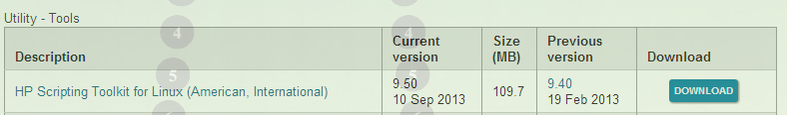

http://h20565.www2.hp.com/portal/site/hpsc/template.PAGE/public/psi/mostViewedDisplay/?javax.portlet.begCacheTok=com.vignette.cachetoken&javax.portlet.endCacheTok=com.vignette.cachetoken&javax.portlet.prp_efb5c0793523e51970c8fa22b053ce01=wsrp-navigationalState%3DdocId%253Dmmr_kc-0100799-7%257CdocLocale%253Den_US&javax.portlet.tpst=efb5c0793523e51970c8fa22b053ce01&sp4ts.oid=5193137&ac.admitted=1385619102958.876444892.492883150

Title: HP ProLiant Gen8 Servers - HP ROM Configuration Utility (HPRCU) Formerly CONREP
Object Name: mmr_kc-0100799
Document Type: Support Information
Original owner: KCS - ProLiant Servers
Disclosure level: Public
Version state: final
Environment
FACT:HP ProLiant Gen8 Server Series
FACT:HPRCU (HP ROM Configuration Utility)
Questions/Symptoms
SYMPTOM:HP ROM Configuration Utility
SYMPTOM:CONREP
SYMPTOM:HPRCU
SYMPTOM:Scripting Toolkit
GOAL:Replicate hardware configuration of one ProLiant server onto another.
GOAL:Manage same BIOS, RBSU settings across all ProLiant Servers.
GOAL:Copy RBSU settings from one ProLiant server onto a new ProLiant server or onto a system board which is replaced.
GOAL:RBSU Settings
Cause
CAUSE:Manage same RBSU settings across all or some ProLiant server within a datacenter.
Answer/Solution
FIX:HPRCU is an RBSU configuration utility similar to CONREP. This utility is supported on Gen8 ProLiant servers and later. HPRCU command-line syntax hprcu -s | -l [-f file.xml ] [ -h ] HPRCU command line arguments: -s This argument saves the system configuration to a file. -l This argument loads the system configuration from a file and writes it to the target server. -f{file.xml} Name of the input or output file. If not specified, the XML configuration defaults to hprcu.xml. -h This argument displays program usage. HPRCU sample XML format: Sample XML format generated by HPRCU is similar to the following: <hprcu> <informational> <product name>ProLiant BL460c Gen8</product_name> <system_rom_family>I31</ system_rom_family > <system_rom_date>15/07/2012</system_rom_date> </informational> <feature feature_id='176' selected_option_id='2' default_option_id=’1’ feature_type='option'> <feature_name>Intel(R) Hyperthreading Options</feature_name> <option option_id='1'><option_name>Enabled</option_name></option> <option option_id='2'><option_name>Disabled</option_name></option> </feature> <feature feature_id='100' feature_type=’string’> <feature_name>Server Name - Line 1</feature_name> <feature_value>SERVERNAME</feature_value> </feature> </hprcu> Reference: Click here for Scripting Toolkit QuickSpecs. Click here for Scripting Toolkit Downloads and Guides. From the above link, refer to STK User Guides for Windows and Linux. Click here to go to HP Guided Troubleshooting.
© Copyright 2013 Hewlett-Packard Development Company, L.P.

Provide feedback
Please rate the information on this page to help us improve our content. Thank you!
Was the information on this page helpful?

Very helpful
Somewhat helpful
Not helpful

http://h20566.www2.hp.com/portal/site/hpsc/template.PAGE/public/psi/mostViewedDisplay?javax.portlet.begCacheTok=com.vignette.cachetoken&javax.portlet.endCacheTok=com.vignette.cachetoken&javax.portlet.prp_efb5c0793523e51970c8fa22b053ce01=wsrp-navigationalState%3DdocId%253Demr_na-c03658056-1%257CdocLocale%253Den_US&javax.portlet.tpst=efb5c0793523e51970c8fa22b053ce01&sp4ts.oid=5177957&ac.admitted=1385559631252.876444892.199480143

HP ProLiant Servers - How to Run CONREP to Disable ASR in Server BIOS

Information
How to disable/Enable ASR in ProLiant BIOS using CONREP utility?

Details
Below steps were performed on HP ProLiant DL380 G6 server running with Windows 2008 x64 SR2 using STK v9.30 for Windows.
- Download and installed the STK package v9.30 (SP56837).
- Upon installing, it will create a folder c:\swsetup to installed and extract all the files.
- Under Windows 2008 x64 SR2.
- C:\swsetup
- Copy the Toolkit I/O driver (hpsstkio.sys ) available at C:\SWSetup\SP56837\x64\drivers\winpe30\system\hpsstkio .
- To the Windows driver directory C:\Windows\System32\drivers .
- To extract the BIOS content of DL380G6 (esessmw0177) server and save the configuration to "filename.xml " file.
- Command: conrep -s -xconrep.xml -f filename.xml .
- Edit the output file to disable the ASR.
- Then uploaded this file to server BIOS to disabled ASR successfully.
- To load the BIOS RBSU content extraction to other servers use the following command:
- conrep -l -xconrep.xml -f filename.xml .
For details please refer the User Guide available at:
Click here to access the User Guide for "HP Scripting Toolkit for Windows and Linux" .
HP Scripting Toolkit includes a modular set of utilities and important documentation that describe how to apply these new tools to build an automated server deployment process.
Keywords : "CONREP" ; "SCRIPTING" ; "ProLiant" ; "ASR" ; "BIOS" ; "STK"

Provide feedback
Please rate the information on this page to help us improve our content. Thank you!

